Human and Linguistic Diversity: Number and Geometry in Mundurukú*
Pierre Pica, UMR 7023 CNRS Paris

Dr. Pierre Pica, who has had a unique opportunity to visit the Mundurukú, an indigenous people of Brazil, will talk about the experience of conducting linguistic field work on a language that has a very limited vocabulary for numbers and geometry. His work has been published in Science (among other places) and has received some attention in the media. Pica’s interpretations of the findings have also been the subject of some debate.
Dr. Pica will address questions including the following:
- How was it that a French linguist came to be in touch with an Amazonian people that has only a few words for numbers and geometrical concepts?
- How was this aspect of the language discovered at all?
- What are the implications of this impoverished vocabulary for daily life?
- Are these people really different from us?
This presentation will address important issues for linguistics and psychology in a way that is accessible to a general audience.

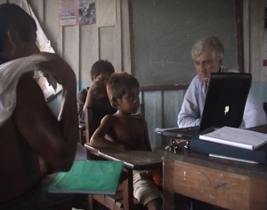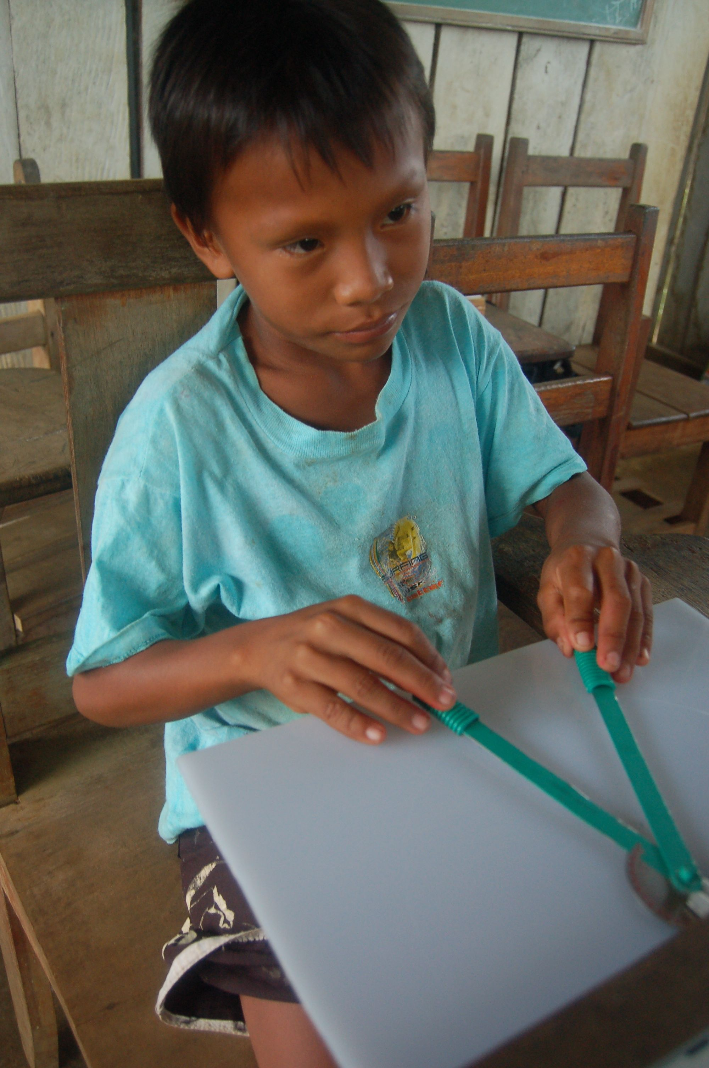
Pictures © Pierre Pica/CNRS
For further information about Dr. Pica’s work and reaction to it, see, for example:
http://alexbellos.com/wp-content/uploads/2010/04/maths.pdf
http://www2.cnrs.fr/en/319.htm
http://www2.cnrs.fr/en/1865.htm?debut=40
http://www.americanscientist.org/issues/pub/can-you-count-your-chickens
http://www.dailymotion.com/video/xehcfl_pierre-pica-emission-avec-j-p-rogel_tech
http://www.nytimes.com/2006/01/24/science/24geom.html
*Sponsored by the BU Linguistics Program (CAS Department  of Romance Studies) http://ling.bu.edu/ in conjunction with the  Boston University Undergraduate Linguistics Association (BULA) | 

