

COLLEGE OF BEHAVIORAL AND SOCIAL SCIENCES

Summer Research Initiative to Increase Diversity

An Overview of the UMD Summer Research Initiative
The Summer Research Initiative was created in 1999 by the Office of the Dean in the College of Behavioral and Social Sciences (BSOS) and is supported by the Office of the Provost, the Graduate School, the Office of the Vice President for Research, the College, and a grant from the National Science Foundation (SBE-AGEP). The goals of the program are to provide rising juniors and seniors an opportunity to increase their interest and learn about doctoral-level training, and provide basic research skills that can be applied in the social, behavioral and economic science fields. The program has a special emphasis on population groups underrepresented in these fields (i.e., African Americans, Hispanics, American Indians, Alaska Natives, Native Hawaiians or other Pacific Islanders).


Program Details
This 8-week program will be held on the University of Maryland, College Park campus from June 1 through July 24, 2009. Students will be provided a meaningful research experience by working with a faculty mentor in one of our nine academic departments: African American Studies, Anthropology, Criminology & Criminal Justice, Economics, Geography, Government & Politics, Hearing & Speech Sciences, Psychology and Sociology. We will also supplement their research experience with lectures, workshops, and networking opportunities.
“Thank you for the opportunity and for acknowledging that there are talented students at minority
institutions.”

-SRI 2000 Scholar

Students will be provided round-trip airfare, meals, room and board in University on-campus housing and a stipend of $2,700.

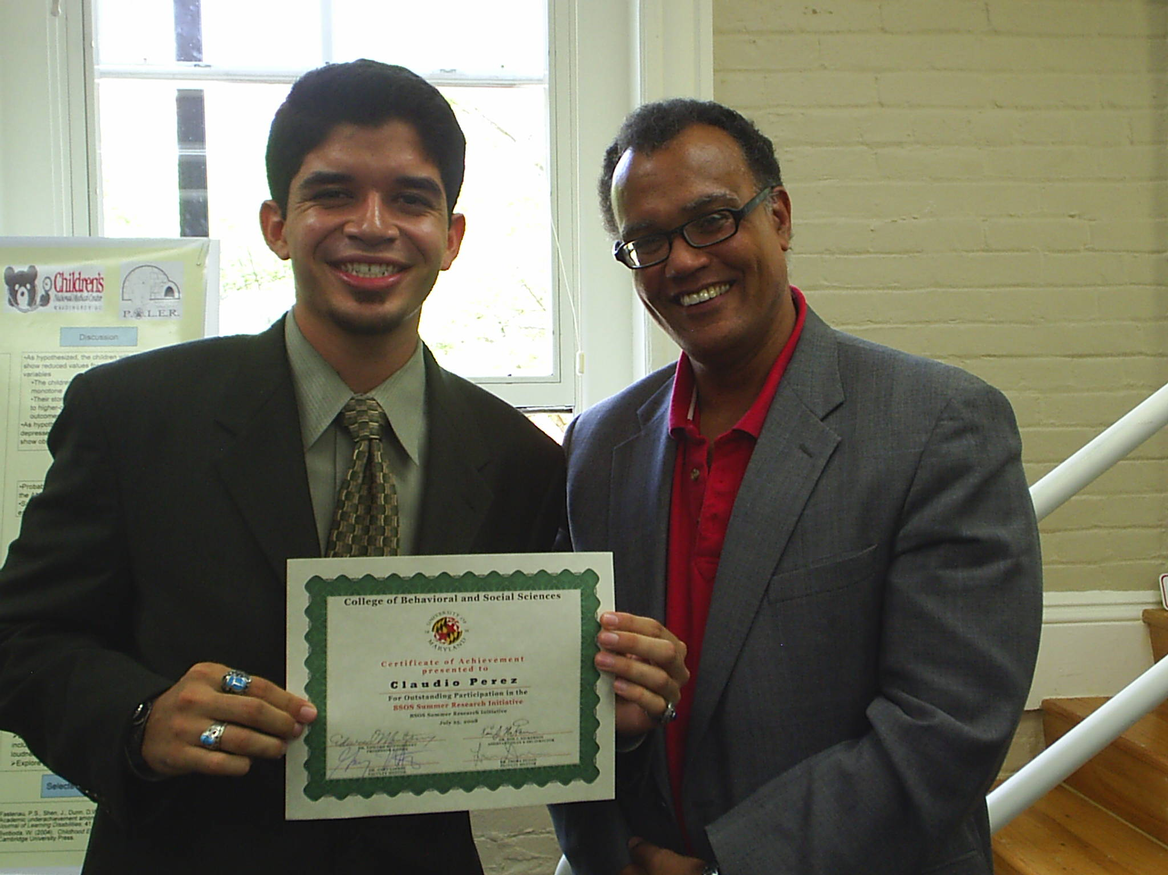
The University of Maryland, College Park is the flagship campus in the University of Maryland system and is home to first-class researchers and research facilities. U.S. News & World Report ranks the University 18th among public universities. According to the NSF, the University ranks 8th in awarding doctoral degrees in the social, behavioral and economic sciences to underrepresented ethnic minorities.

The university’s location, just nine miles from downtown Washington, D.C. and approximately 30 miles from Baltimore, provides access to some of the finest libraries, research centers, and professional opportunities in the country. The D.C. metro area is nationally regarded for its dense population of highly educated and trained professionals, diversity, culture and entertainment.
SRI 2008 Scholar

How to Apply
Basic eligibility requirements include (but are not limited to) junior or senior status by Fall 2009; U.S. citizen or permanent resident status; and a strong intent to immediately pursue a Ph.D. in the social, behavioral, and economic sciences upon completion of the Bachelors degree. We are especially interested in applications from students underrepresented in the social, behavioral, and economic sciences. The application deadline is February 13, 2009.

For more information, please visit: http://www.bsos.umd.edu/dean/summer.html
Or contact Dr. Kim J. Nickerson at SRI@bsos.umd.edu

